

**Software Engineering and Testing. BSC Year 2, 2024/2025**

**Assessment 2: Requirements Document**

**Submitted by: Names, Student numbers**

**B00160049 Matthew Keenan**

**B00159340 Stanislav Kolev**

**B0016388 Fabio Melilo**

**Submission date**

**24/2/2025**

**Declaration**

I hereby certify that this material, which I now submit for assessment on the programme of study leading to the award of Ordinary Degree in Computing in the Institute of Technology Blanchardstown, is entirely my own work except where otherwise stated.

Author: Matthew Keenan Dated: 24/2/2025

Author: **Stanislav Kolev** Dated: 24/2/2025

Author: **Fabio Melilo** Dated: 24/2/2025

Table of Contents:

* Project Overview Pg 4
* Document Revision Pg 4
* Scope Pg 4-5
* Walk Through Scenario Pg 5
* Preliminary Software Requirements Analysis: Pg 5-10
* Graphical User and Interface Design Pg 10-13
* Technical Requirements and Feasibility Pg 14
* Conclusion Pg 14

Tite:

Director’s Cut: Movie Booking and Recommendation System

Client:

Arnold Hensman

1. Project Overview

Our project is a functional movie booking system that allows you to choose from a selection of movies to pick a time and book the movie and receive an e-ticket. It also functions as a movie recommendation website allowing you to choose a genre and receive movie recommendations based on said choice.

1. Document Revision

17/2/2025: Use Case and Requirements were added to Version 1

18/2/2025: Finished off the Scope Paragraph

22.2.25: Completed the remainder of the document

1. **Scope**

This project will be designed to meet the requirements of your average movie watcher with this in mind it must include a functioning booking system including a selection of movies with a description and an option to book or review the movie though login will be required to do so.

Required: 1. Booking System

The booking system will allow the user to input payment information to confirm the booking and will a random String that will function as the users e-ticket

Optional Additions

The booking system will be a sit selection option before or after payment.

Excluded Additions

Individual QR codes for tickets are excluded

Required: 2. Movie Recommendation System

The recommendation system will give the user the ability to find a new movie too by allowing them to access a filtering system by genre and once the genre is selected a certain number of movies with a tag/variable matching the genre. After that the user can continue to the booking system by clicking the booking option

Optional Additions

. A Link to a streaming service like Netflix to allow you to watch it online

. Either a manually made SQL database or API for data generation we haven’t decided on which yet

. Movie searching

Required 3: Movie Reviews/Comments

This feature will make the website useful to users who already watched the movie their recommended as they will be able to click on review and leave a text description of their thoughts on the movie

Optional Additions

. A star rating system under the review comment

Excluded Additions

. Allowing images in the reviews

1. **Walk-Through Scenario**

User

The user will enter the website’s home page where they can access the movie recommendations by selecting filter on the page and selecting their desired genre. Once confirmed is click the page will display a selection of films with tags/variable matching the selected genre. From which the user can select a movie (A Movie on our website will include title, description, genre) and either click on booking and begin the booking process were the user will be asked to input payment information and after which a prompt appears to pay for the ticket and a e-ticket string will be given to the user or click review in which case a text area will pop up, allowing the user to input their opinions on the movie they chose and display it on the movies page (you must be login to review a movie)

Separately from movie booking or reviewing. Users will have a profile created after they login. The information in the profile will match the information with an additional profile picture the user can select from a limited number of images

1. **Preliminary Software Requirements Analysis:**

**Functional:**

Buying Feature - Shopping

* Allows users to add movie tickets with booking time and desired seat into shopping cart.
* Shopping carts lead to a checkout screen which will prompt banking details.

E-Ticket Signature - Ticketing

* After a purchase is successful an E-Ticket signature will be created. That could theoretically be used to print tickets at the cinema in person.
* The signature is a randomly generated string using JavaScript.
* Printable Ticket

Recommendation System - Recommendations

* Once clicked on a desired movie the user will be put into the times and seats screen this will also contain a section that recommends movies that are of the same genre using JSON.
* The user will be able to navigate to the movies in this selection, this allows them to purchase tickets for the recommendations.

Movie Browsing - Searching

* The movie browsing page displays movies available for purchase through JSON database. The database can also be queried using search functions.
* Each movie will lead to its own page that contains the price and times that are available, the user will also get to choose their desired seat.

Reviews – Movie Reviews

* Users can leave written reviews on movies they have watched.
* Reviews can include a rating system (e.g., 1-5 stars).
* Displayed reviews will be fetched from a database using JSON.

Profiles Reviews - User Rating of Reviews

* Each user profile will have a review system, for there reviews like a thumbs up and thumbs down on the reviews.

Profiles Friending - Friending

* Users will be able to friend each other and look at each other’s profiles.

**Non-Functional:**

Age restrictions

* Users must verify their age before purchasing tickets for age-restricted movies.

Dates

* Showtimes will be displayed in chronological order.
* The system will prevent booking conflicts (e.g., double-booking the same seat).

Prevent Inappropriate Content on Reviews

* User-generated content, such as reviews, will be monitored for inappropriate language.
* Automated filtering and moderation tools will be used to detect offensive words.

Reviews

* The highest liked reviews will show up first.

Friending

* The newest friend profile appears first in the friends list.

USE CASE

**CASE 1: Customer Knows What to Watch:**

Book Movie:

. click on movie page

. click booking option

. select appropriate time

. login to allow you to book

. select sitting

. continue to payment screen

Display Prices

. shows the user the cost of the ticket

. display option to enter payment details

Pay

. Input Payment Information:

* Name
* card number
* cvc
* zip code

. Confirm payment transaction

. Pay for the movie

Don’t Pay

. Asked to Input Payment Details

. Click decline

. return to movie page

**CASE 2: Customer Can’t Decide What To Watch**

Find A Movie:

. go to the recommended movies page

. filter by the type of movie you want e.g. Genre: action

. choose from recommended movies

. click on movie

Book Movie:

. click booking option

. select appropriate time

. login to allow you to book

. select sitting

. continue to payment screen

Display Prices

. shows the user the cost of the ticket

. display option to enter payment details

Pay

. Input Payment Information:

* Name
* card number
* cvc
* zip code

. Confirm payment transaction

Don’t Pay

. Asked to Input Payment Details

. Click decline

**CASE 3: Reviewer**

Login

. Select register/login

. Input login details

-name

-age

-phone number

. confirm information

. profile is created

Pick A Movie

. Go to a movie page you have previously watched

. click on the movie page

. click on review button

Review Movie

. Fill out description on your thoughts on the Movie

. Select score of enjoyment

. Confirm you want to finalize and publish review by clicking confirm

**CASE 4: Profile Creation**

Login

. Select register/login

. Input login details

-name

-age

-phone number

. confirm information

. profile is created

Go to Profile

. Select profile option on the menu

. It will display the information given in login

Add Profile Picture

. Select and add profile picture

. select from a limited number of images

. Click confirm to select it as your profile

. The image is displayed with the profile information

1. **Graphical User Interface Design**

Home Page

Movie Page

Booking Page

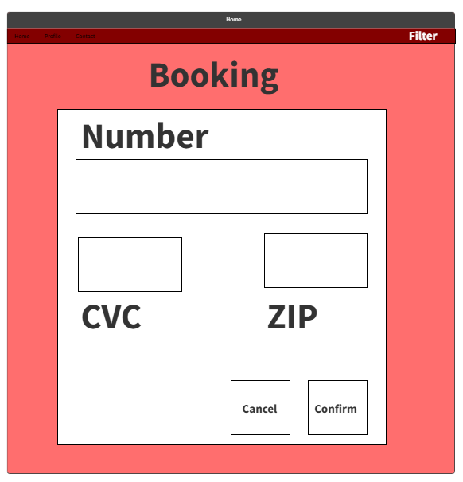

1. **Technical Requirements and Feasibility:**

System Model:

The model will be done using a UML Diagram (Class Diagram) which will take from the use case diagram shown above. All diagrams will be available as screenshots to keep track of the progress of the project

Development Language

There will be a couple coding languages used within this project including mainly php and html for the function and design of the website and potentially Json to store data from the movie data base

Persistent Storage

As of now the only form of persistent storage will be SQL and Json as the information for the profile and the movies will be acquired and stored using SQL and then accessed by the website using Json.

Interface

The interface of the website will be developed using html and php. Html for look and feel using CSS and php for the functionality of the website

1. **Conclusion**

After showcasing the detail of the project, we feel the project will meet all the requirements outlined in this document:

Buying Feature – Shopping**,** E-Ticket Signature – Ticketing**,** Recommendation**,** Movie Browsing, Reviews, Profiles Reviews - User Rating of Reviews**,** Profiles Friending – Friending

Everything above seems very feasible as its primally input and storage of data along data generation with the e-ticket, all this is shown above with the use case diagram and spec.

Our main concerns in terms of implementation are securing the inputted data, the search function and organizing that amount of data